User Guide

Waste 2 Resource calculator

2024

Contents
1 Introduction 1
1.1 Definition of terms 1
1.2 Scope 1
1.2.1 In Scope 1
1.2.2 Out of scope 2
1.3 How the calculator applies to project delivery phases 2
2 Calculator setup 2
3 How to use the Calculator 3
3.1 INPUT tab – Project and Contract information 3
3.2 INPUT tab – Actual Waste Quantities 4
3.3 INPUT tab - Recycled Material Quantities 5
3.4 Actual – Monthly tab 6

Introduction
This document explains how to use the Waste 2 Resource Calculator (the Calculator). The Calculator has been developed to assist projects with:
- estimating the amount of waste, a project will generate.
- tracking actual waste quantities generated monthly.
- recording actual waste quantities generated by practical completion; and
- recording the amount of recycled materials used in a project.

Definition of terms
The terms used in this User Guide shall be as defined in Table 1.1.
Table 1-.1 Definition of terms
Term | Definition
Disposed | Quantity of discarded or discharged material waste that has been disposed of at landfill facilities in accordance to prescribed legislation.
Generated | Quantity of material or products that enters a waste stream before composting, incinerating, landfilling, or recycling.
ISCA | Infrastructure Sustainability Council of Australia
Recycled | Quantity of waste material that is recovered and used as an input or resource product (for example, concrete pavement is crushed and made into subgrade material).
Reused | Quantity of waste material reused before replacing (for example, excess earthworks is reused within a project to avoid import of material).

Scope

In Scope
The Calculator is applicable to a variety of transport infrastructure projects including road, rail and boat ramp infrastructure.
Typical contract types that the Calculator applies to are:
- Transport Infrastructure Contracts (TIC) including Contract Only (TIC-CO), Sole Invitation (TIC-SI), Design and Construct (TIC-DC)
- Minor Infrastructure Contracts (MIC)
- Road Asset Management Contracts (RAMC)
- Collaborative Project Agreements (CPA), and
- Consultants for Engineering – Functional Specifications for Detailed Design.
The project specific waste-related requirements are specified within the project’s contractual documentation.

Out of scope
Out of scope for project waste reporting includes:
- suppliers’ waste (to avoid double reporting)
- litter outside of project generated waste
- septic waste that is connected to sewer
- emissions
- naturally occurring radionuclides / asbestos, and
- water captured in sediment basins.

How the calculator applies to project delivery phases
Typically, the Calculator will be used during the detailed design and construction phases of an infrastructure project in the following ways:
- in detailed design phase to generate a waste estimate for the project,
- during construction phase to track and report actual waste volumes for projects, and
- for operational works contracts (maintenance contracts) to estimate waste volumes and record waste volumes.
Reporting is required for:
- Detailed Design Contracts and is specified in the Functional Specifications Detailed Design (C7524 Annexure),
- Projects that are undertaking an ISC rating need to complete a waste estimate,
- All Construction and Maintenance Contracts as part of MRTS51 Environmental Management, and
- TMR’s submission to DESI as required by the Waste Reduction and Recycling Act 2011.

Calculator setup
The Calculator has multiple tabs as shown in Figure 2-1 and described in Table 2-1. The tabs where data can be entered have been coloured green. Tabs that are for information are the stone colour. Tabs that are for data quality and processing are coloured black.
Figure -1 Spreadsheet tabs

Table 2-1 Tab descriptions
Tab name | Tab description
INPUT | This tab is the starting point of the Calculator. This is where contract information is input. This tab is also where total waste quantities for a contract can be entered.
ACTUAL - Monthly | This tab allows users to input monthly waste tracking data. This is relevant to projects undertaking an Infrastructure Sustainability Council of Australia (ISCA) rating.
ESTIMATE | This tab provides estimated waste quantities for each waste stream. The quantities are automatically calculated based on the user inputs on the ‘Input’ tab, and a range of background calculations based on historical Transport and Main Roads data.
USER GUIDE | This tab provides an ‘in-Calculator’ guidance on the various user inputs.
CONVERSIONS | This tab provides a useful guide for converting various waste volumes into a weight for different waste types.
Lookups | This tab includes lists that are used to control the values which can be input. This tab is hidden for most users.
Raw Data | This tab is where data entered is converted into a standard format to allow for collation of all submitted data. This tab is hidden for most users.

The cells in the Calculator have been coloured so that the input cells are clear. The colour coding for the cells is shown in Figure 2-2. Protection has been applied to the Calculator so that only the input cells can be edited.
Figure 2-2 Colour coding
Input cell – users can input data whether a drop-down menu or user defined input.
Report cell – the Calculator automatically populates these cells.

The Calculator is collecting information on the waste generated and the destination for that waste which can be reuse, recycled or landfilled. There are data quality checks in the Calculator to ensure that the total generated equals the sum of the quantity reused, recycled or landfilled.

How to use the Calculator

INPUT tab – Project and Contract information
The Input tab must be used to provide information on the project or contract that is submitting data.
Table 3-1 Input information
Input question | User guidance
Is this project in a waste levy zone? | Select "Yes" or "No" from the drop-down list.  Refer to the levy zone map for further guidance, or find additional information here:  https://www.qld.gov.au/environment/pollution/management/waste/reco very/disposal-levy/about/waste-levy-map
TMR District | Select the Transport and Main Roads District from the drop-down list.  For contracts over District boundaries, simply nominate a primary District to refer to.
Contract Name | Enter the Contract Name.
Reporting Date (dd/mm/yyyy) | Enter the Reporting Date in dd/mm/yyyy format.  For Estimates, the reporting date should be the date the Calculator is used to generate an estimate.  For Actuals, the reporting date should be the Practical Completion date to capture final actual waste quantities for the project.
Submitted By (Name of Contractor) | Enter the name of the Contractor Company.
Investment ID | Enter the Transport and Main Roads Investment ID.
Contract ID | Enter the Transport and Main Roads Contract ID.
Infrastructure Type | Select the infrastructure type from the drop-down list.
Project Value | Select the Project Value from the drop-down list.  Projects >$100M would be expected to be answer "Yes" to Question 2 "Is this project undertaking an ISCA rating?".
Project Type | Select the Project Type from the drop-down list.  Refer to the 'Additional Guidance' section embedded within the Calculator for further guidance.
Area of pavement surface works (m²) | Enter the area, or footprint (in square meters) of pavement surface works.
Extent of Clearing and Grubbing (m²) | Enter the area, or footprint of vegetation clearing and grubbing. Refer standard item 32001.
Contract Duration (months) | Enter the Contract Duration to the nearest whole month (numerical value). Note that the spreadsheet Actual – Monthly Tab only includes 24 months of data, for longer project Duration develop multiple Calculators or request custom template.
Average width of paved surface (m) | Enter the average width of the paved surface throughout the Project, to one-decimal-place (numerical value).
Length of road (km) | Enter the length of the Road Project, to one=decimal-place (numerical value)

INPUT tab – Actual Waste Quantities
At the completion of a project the total waste quantities can be entered into the table shown in Figure 3-1.
Figure 3-1 USER INPUT - Actual Waste Quantities
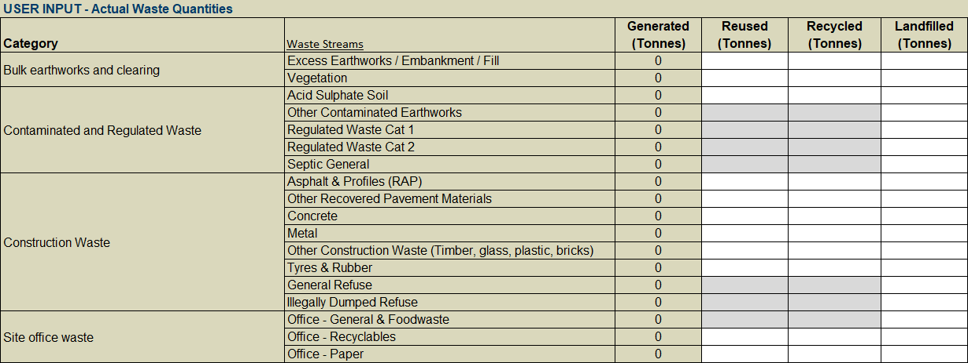
Data must be entered into the ‘USER INPUT - Actual Waste Quantities’ or the ‘USER INPUT - Monthly Waste Quantities’ on the ‘ACTUAL – Monthly tab’. If data is entered into both, a reminder message will show above the tables that only one input method should be used.

INPUT tab - Recycled Material Quantities
All projects are asked to enter quantities of recycled materials used in the project on the ‘Input’ tab (Figure 3-2). Recycled materials should be selected from the listed material type or custom materials can be entered into the table. The intention of collecting this information is to identify where recycled materials are being used on projects. Materials that are generated on the project and are sent to a recycled materials processor should not be recorded in this table.
The quantities provided should be of the specific recycled material constituent (IE quantity of recycled glass cullet used in unbound granular pavement) rather than the quantity of the mixed product.
The User is prompted to identify the application the recycled material was used in and where possible the applicable work item.
Figure 3-2 USER INPUT - Recycled Material Quantities
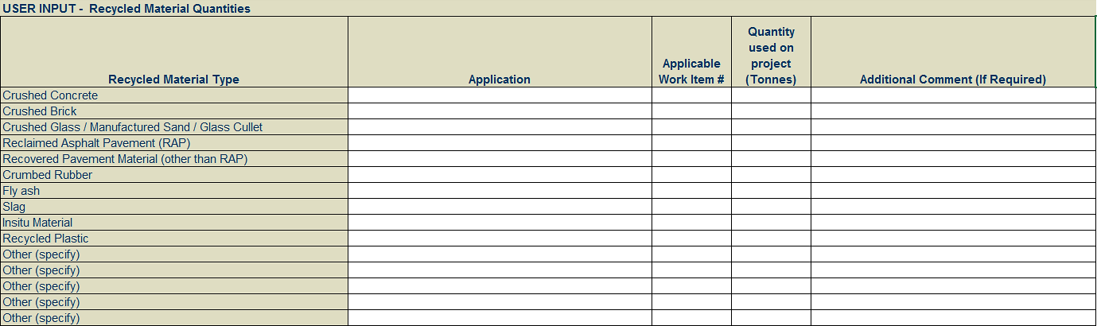

Project teams to note the following:
- All projects are encouraged to populate recycled material quantities, where known.
- Recycled material quantities should be based on the ‘actual’ quantities over the project contract period (that is, the date the contract was signed through to Practical Completion).
- All input quantities should be in metric Tonnes. A conversion chart is provided on the ‘Conversion’ tab of the Calculator.
- Where there is no quantity for a particular material type, leave blank.

Actual – Monthly tab
The ACTUAL – Monthly tab allows for the input of waste data monthly, rather than as a single value at the completion of the project or contract. The table at the top of the sheet is a summary of the data entered.
The table has been setup so that the ‘Month, year’ column will automatically populate based on the start of contract date that has been entered. Allowance has been made for 24 months of data. Where projects will exceed this duration, they can use and submit multiple Calculators to cover the entire project. Alternatively, projects can email the projectwasteregister@tmr.qld.gov.au and request a custom template.
Maintenance contracts that include multiple locations must be reported in a single Calculator at the completion of the maintenance contract. There is a notes text box that can be used to describe all the locations included in the Calculator.
Data must be entered into the ‘USER INPUT - Actual Waste Quantities’ or the ‘USER INPUT - Monthly Waste Quantities’ on the ‘ACTUAL – Monthly tab’. If data is entered into both, a reminder message will show above the tables that only one input method should be used.

User guide tab
The Calculator includes a User Guide Tab which provides references and instructions to the user on how to use and complete the Calculator.

Waste categories and waste streams
The Calculator is built around four defined waste categories, as per the following Table 4-1.
Table 4-1 Waste category descriptions
Waste Category | Description
Bulk earthworks and clearing  (Not contaminated) | This category includes 'natural' waste streams generated through bulk earthworks / civil engineering activities.  This category includes any non-contaminated waste.
Contaminated and Regulated Waste | This category includes streams classified as regulated waste under The Environmental Protection (Waste ERA Framework) Amendment Regulation 2018, and which are not specified in any other category.  Refer here for further guidance: https://environment.des.qld.gov.au/waste/review-reg-waste.html.
Construction Waste | This category includes streams which are 'man-made' and generated through construction activities.
Site Office Waste | This category includes any waste streams generated through office activities, such as general waste, recyclables, and paper.
Within each waste category, a wide range of waste streams are provided for project teams to report against. Streams have been selected for the Calculator based on an analysis of typical waste streams on Transport and Main Roads projects. A description of each stream is provided in the following Table 4-2.
Table 4-2 Waste stream descriptions
Waste Stream | Description
Excess Earthworks / Embankment / Fill | Any excess earthworks, embankment or fill generated by a project then exported outside the project boundary for reuse, recycling, or landfill beyond the project boundary.
Vegetation | Timber vegetation stripped grasses and so on.
Acid Sulphate Soil | Acid Sulphate Soils
Other Contaminated Earthworks | Any other contaminated earthworks, but not acid sulphate soils.
Regulated Waste Cat 1 | Regulated waste is Category 1 regulated waste if it meets the requirements of Section 43 of the Environmental Protection Regulation 2019.
Regulated Waste Cat 2 | Regulated waste is Category 2 regulated waste if it is not Category 1 regulated waste.
Septic General | Septic waste generated by projects
Asphalt and Profiles (RAP) | Asphalt only (not chip seals and other pavements)
Other Recovered Pavement Materials | Spray seal pavements, stabilised pavements (not asphalt)
Concrete | Structural concrete, shot crete, hardened grout, concrete washout
Metal | Signposts, guardrails and so on
Other Construction Waste (timber, glass, plastic, bricks) | Any construction waste not accounted for in other construction waste categories, such as uncontaminated timber, glass, plastic, and bricks
Tyres and Rubber | Waste tyres
General Refuse | Cardboard, plastic packaging
Illegally Dumped Refuse | Waste collected from road reserve
Office – General and Food waste | Putrescibles, kitchen waste, non-recyclable packaging
Office – Recyclables | Mixed recyclables including plastic plates, bottles, aluminium cans and so on.
Office – Paper | Paper and cardboard recyclable waste

Waste levy zone map
The levy zone includes 39 out of 77 local government areas in Queensland, which covers around 90% of Queensland’s population and is where most of the waste is generated and disposed.
The exclusion of some local government areas recognises the different circumstances faced by remote and less populated communities in Queensland, and removes the costs of administering, remitting and reporting against the levy in these regional areas.
The waste levy zone map (Figure 5-1) can be accessed via the following Queensland government webpage:
https://www.qld.gov.au/environment/pollution/management/waste/recovery/disposal- levy/about/waste-levy-map
Figure 5-1 Queensland waste levy zones and boundaries
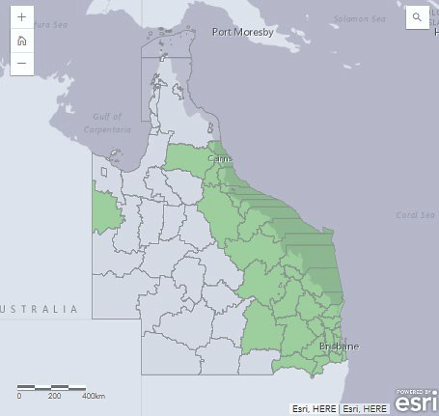

Submitting Waste Report to the department
The completed Calculator shall be submitted to the following Transport and Main Roads email inbox, projectwasteregister@tmr.qld.gov.au
As the Calculator should be submitted at practical completion, only one file should be submitted for each contract. The Calculator should not be submitted monthly. Where this happens, the submission will be rejected and the person submitting the Calculator will be asked to follow the correct process. The User is required to name the file according to using this naming convention Contract#_ContractName.xlsx
For example: CN45678_BloggsRoadUpgrade.xlsx
The Consultant and Contractor shall cc the Contract Administrator and/or Transport and Main Roads Project Manager to the email for contract administrative purposes.
For construction and maintenance projects, the completed actuals shall be submitted at Practical Completion.

